Plus ancienne recette documentée ?

https://blogs.bl.uk/digitisedmanuscripts/2017/01/address-to-a-medieval-haggis.html

Medieval manuscripts blog

25 January 2017

Address to a Medieval Haggis
Today we celebrate the birthday of Scotland’s national poet, Robert Burns (1759–1796). Robert Burns was born in Alloway, a small village near the river Doon just south of Ayr in south-west Scotland. He was made famous by his innovative volume of verse, Poems, Chiefly in the Scottish Dialect, first published in Kilmarnock, Ayrshire in 1786. Burns is perhaps best known for composing the poem ‘Auld Lang Syne’, which is to this day sung to ring in the New Year. Every year on 25 January, Scotland and the world celebrate his literary legacy by hosting Burns Night suppers with delicious treats such as neeps and tatties, and the famous Scottish dish of haggis. The British Library holds one of the oldest known recipes for haggis in a text composed around 1430, the Booke of Curtassye (now Sloane MS 1986). The recipe for ‘hagese’ features in English verse along with references to potages, roasted meats and humble pie. The whole collection is translated here.
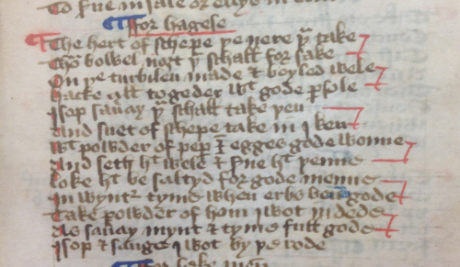
Address to hagese: one of the earliest recipes for haggis, Sloane MS 1986, f. 55r
For hagese
The hert of schepe the nere thou take
Thou bowel noȝt thou schall forsake
On the turbilen made & boyled wele
Hacke all togeder wit gode parsole
Isop saueray thou schall take then
And suet of schepe take in I ken
Wit powder of peper & egges gode wonne
And seth hit wele & serue hit thenne
Loke hit be saltyd for gode menne
In wynter tyme when erbs ben gode
Take powder of hom I wot in dede
As saueray mynt & tyme full gode
Isop & sauge I wot by the rode
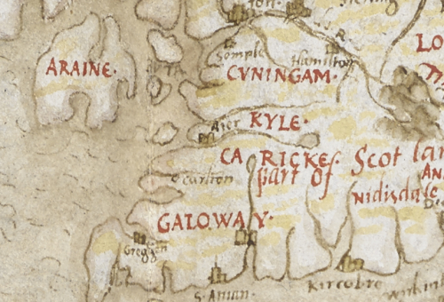
The town of Ayr appears as ‘Aier’ in the 16th-century Nowell-Burghley Atlas, Add MS 62540, f. 4r
If you are inclined to try a more exotic haggis, look no further than this 15th-century English recipe for pudding of porpoise that appears in a cookbook of extravagant banquets (now Harley MS 279). Prepared in the same manner as traditional haggis made with sheep’s stomach, one must mix porpoise blood, porpoise grease, oatmeal, salt, pepper and ginger, then stuff the ingredients into the porpoise stomach before cooking. Perhaps this dish should be served with a side of 'dolphinoise' potatoes?
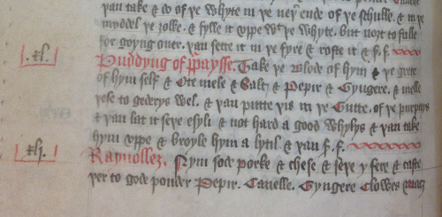
Great chieftain o’ the porpoise pudding-race! Recipe for 'puddyng of purpaysse' in Harley MS 279, f. 32v
However you choose to celebrate Burns Night, remember to raise your dram to the Scottish bard!
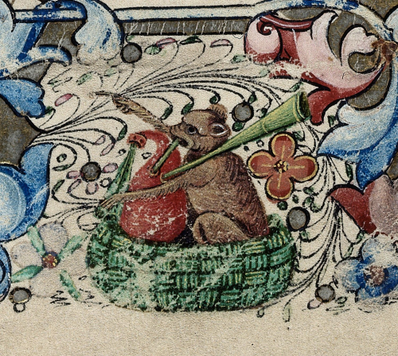
Bagpipes, from the Hours of the Earls of Ormond, England (London), c. 1460, Harley MS 2887, f. 29r
Alison Ray
Follow us on Twitter @BLMedieval
Posted by Ancient, Medieval, and Early Modern Manuscripts at 12:01 AM

